This white paper dives into a fascinating trend: while overall spending may be tighter, the ultra-premium segment in wine and spirits is thriving. Why? It turns out Millennials are willing to pay for more than just taste—they want experiences, authentic brand stories, and a sense of exclusivity. Have you noticed this shift yourself?

Get your free download below to learn more

### **Beyond the Price Tag: Unlocking Premiumization in Wine and Spirits**

According to [IWSR Drinks Market Analysis](https://www.theiwsr.com/premiumisation-is-slowing-but-theres-a-counter-trend/), a fascinating shift is occurring in the beverage alcohol market. While the overall growth of premiumization may be slowing down due to economic pressures, a counter-trend is emerging: the ultra-premium segment continues its strong upward trajectory. This means that while consumers may be more cautious about spending overall, they're still willing to invest in truly exceptional and high-quality drinks.

IWSR data reveals that this trend is fueled by a new generation of consumers - Millennials who are increasingly interested in experiences, brand stories, and social connections. They're not just looking for a great-tasting drink; they're seeking brands that align with their values and offer a sense of community and exclusivity. This shift has significant implications for how wine and spirits brands approach premiumization.

In our latest blog post, we delve deeper into the concept of premiumization, exploring the key elements that contribute to perceived value and outlining strategies for brands to effectively elevate their offerings in this evolving market. We'll discuss how to craft compelling brand narratives, create unique experiences, and tap into the desires of this new generation of discerning drinkers.

#### **What Premiumization Really Means**

At its core, premiumization is about increasing a product’s perceived value to justify a higher price point. While brands in mature markets often struggle with price wars, premiumization shifts the focus to quality, story, and exclusivity, encouraging consumers to view these products as worth the investment. Effective premiumization doesn’t just attract higher prices but builds a sustainable brand reputation.

A premium brand is one that consumers associate with more than just a product; it’s an experience or status symbol that meets multiple facets of their desires. In wine and spirits, this can be achieved by blending a brand’s tangible attributes—such as production method, ingredients and aging—with intangible ones, like emotional and ethical values.

#### **Key Components of Perceived Value**

Premiumization strategies often revolve around four key value components that together shape how consumers perceive a brand’s worth:

1. **Functional Value**: The tangible, performance-driven qualities of the product.
2. **Emotional Value**: The sensations and experiences consumers associate with the product.
3. **Symbolic Value**: Social recognition and identity formation, where the brand serves as a marker of lifestyle or values.
4. **Ethical Value**: The alignment with consumers' ethical standards, whether environmental, social, or otherwise.

As brands elevate their positioning, these components should be thoughtfully integrated. While functional value is foundational, premium consumers will expect emotional, symbolic, and ethical connections with the brands they support.

#### **Examples of Premiumization in Action**

To illustrate how brands can integrate these values into their offerings, here are strategies that effectively add layers of meaning to the product:

* **Emotional Value**: Create immersive experiences. Champagne brands successfully added emotional value by sponsoring movie premiers, sports trophy ceremonies, where the brand is synonymous with luxury, celebration, and tradition. Wineries and spirits brands can replicate this by looking beyond curated vineyard tours and private tastings, and build emotional connections with customers by using authentic storytelling, understanding their audience, and creating meaningful touchpoints to develop a sense of connection and excitement around the brand. Brands need to apply the same principles they would apply to fostering any relationship, honesty, transparency and being there when it matters.

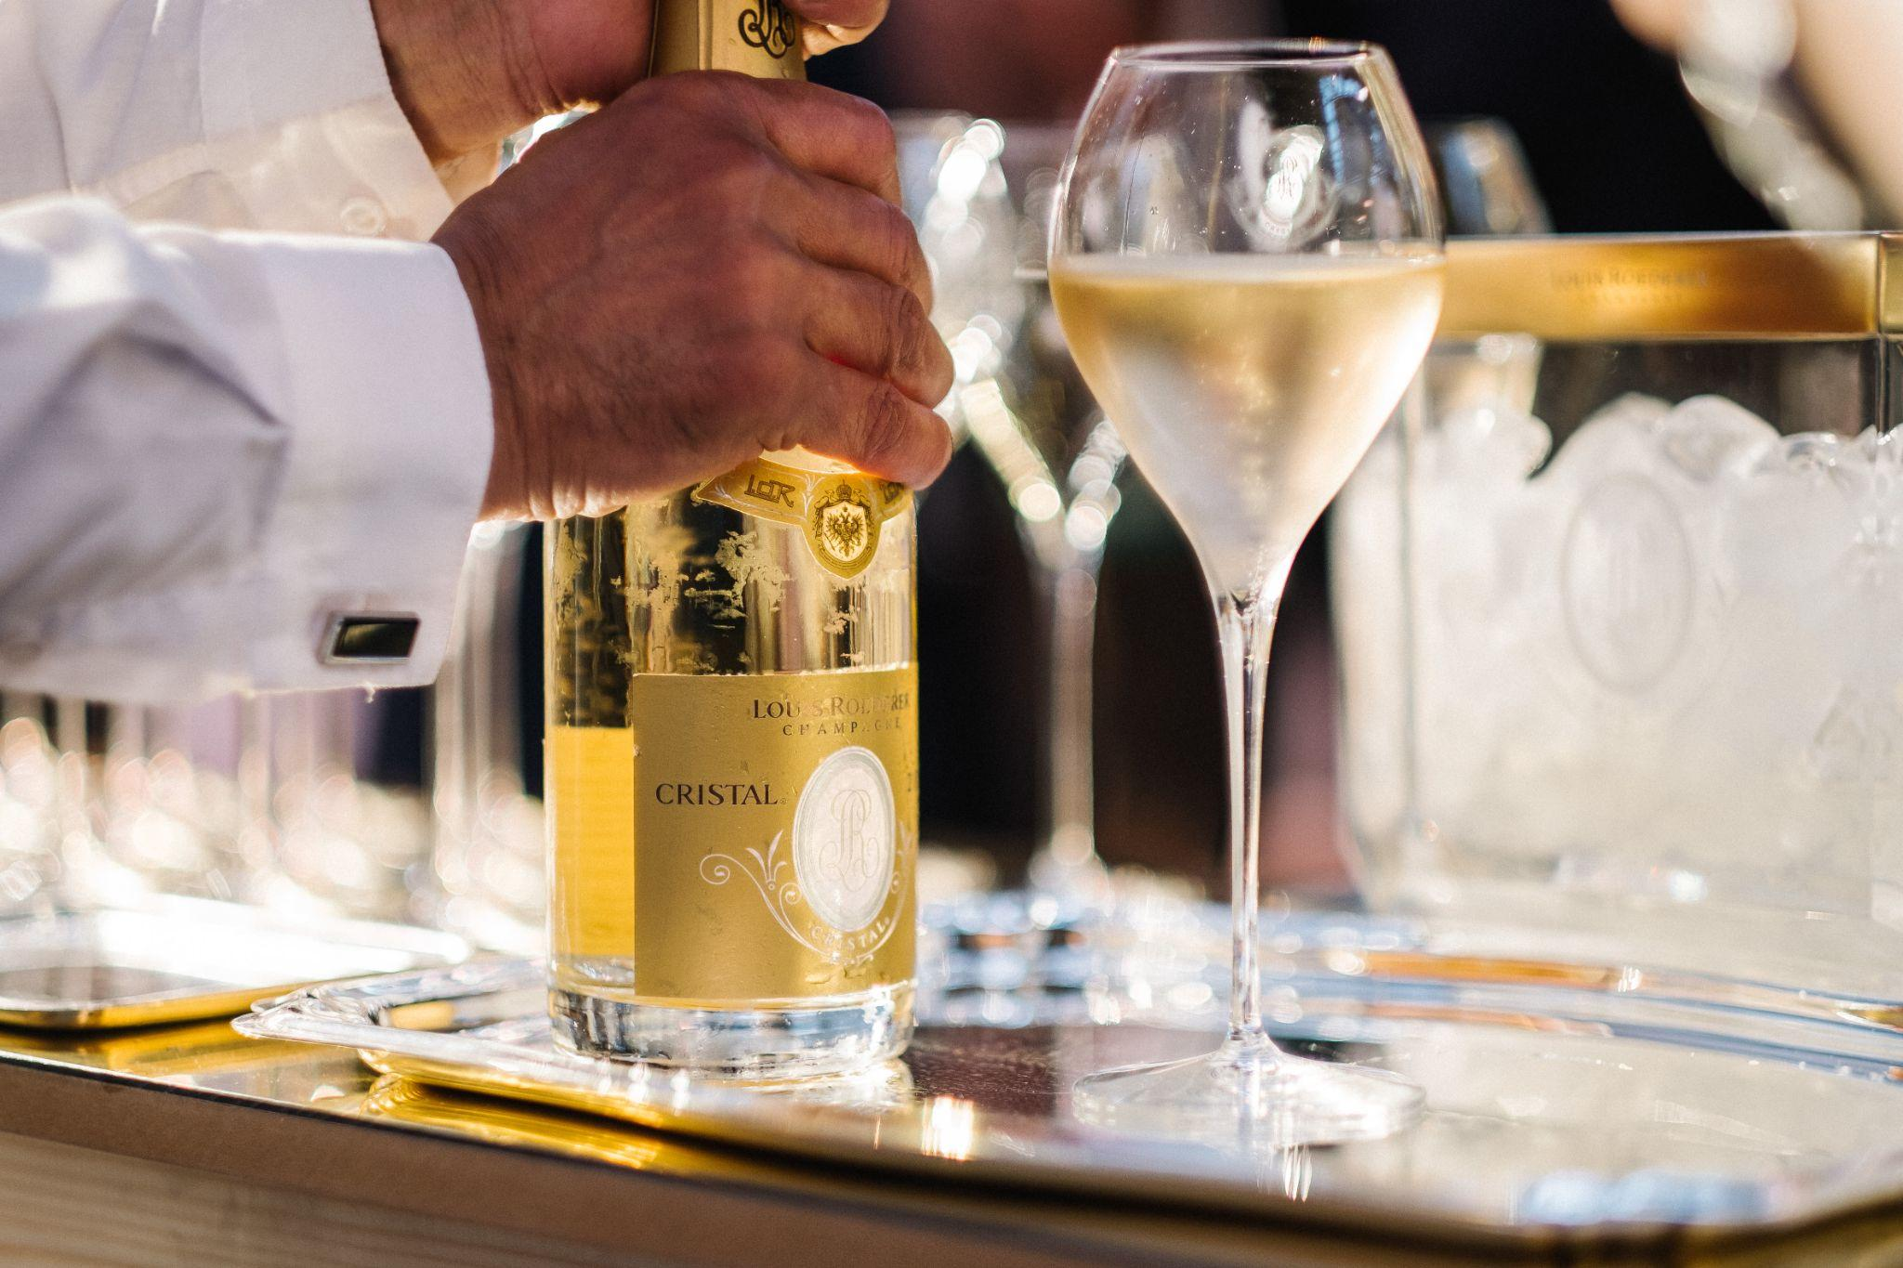

Convinced of the contribution the Arts make to a greater understanding of the world, fostering mutual respect and representing a catalyst and vector of social and environmental change, the [Louis Roederer Foundation](https://www.louis-roederer.com/en/foundation) supports contemporary artistic creation and the transmission of knowledge

* **Symbolic Value**: Align the brand with aspirational lifestyles. Luxury wines and high end spirits are often seen as symbols of status and success, becoming an accessory to luxurious lifestyles. Symbolic value can be built by focusing on storytelling around heritage, exclusivity, and association with sophisticated occasions or similarly luxurious brands in other categories
* **Ethical Value**: Highlight sustainability and community. Brands can make consumers feel good about their purchases by supporting causes that their customers also believe in. These types of partnerships not only boost the brand's ethical profile but also attract socially conscious consumers who value contributing to a greater good with their purchase. For wine brands, sustainable vineyard practices, conservation efforts, or contributions to local communities can be powerful in establishing ethical value.

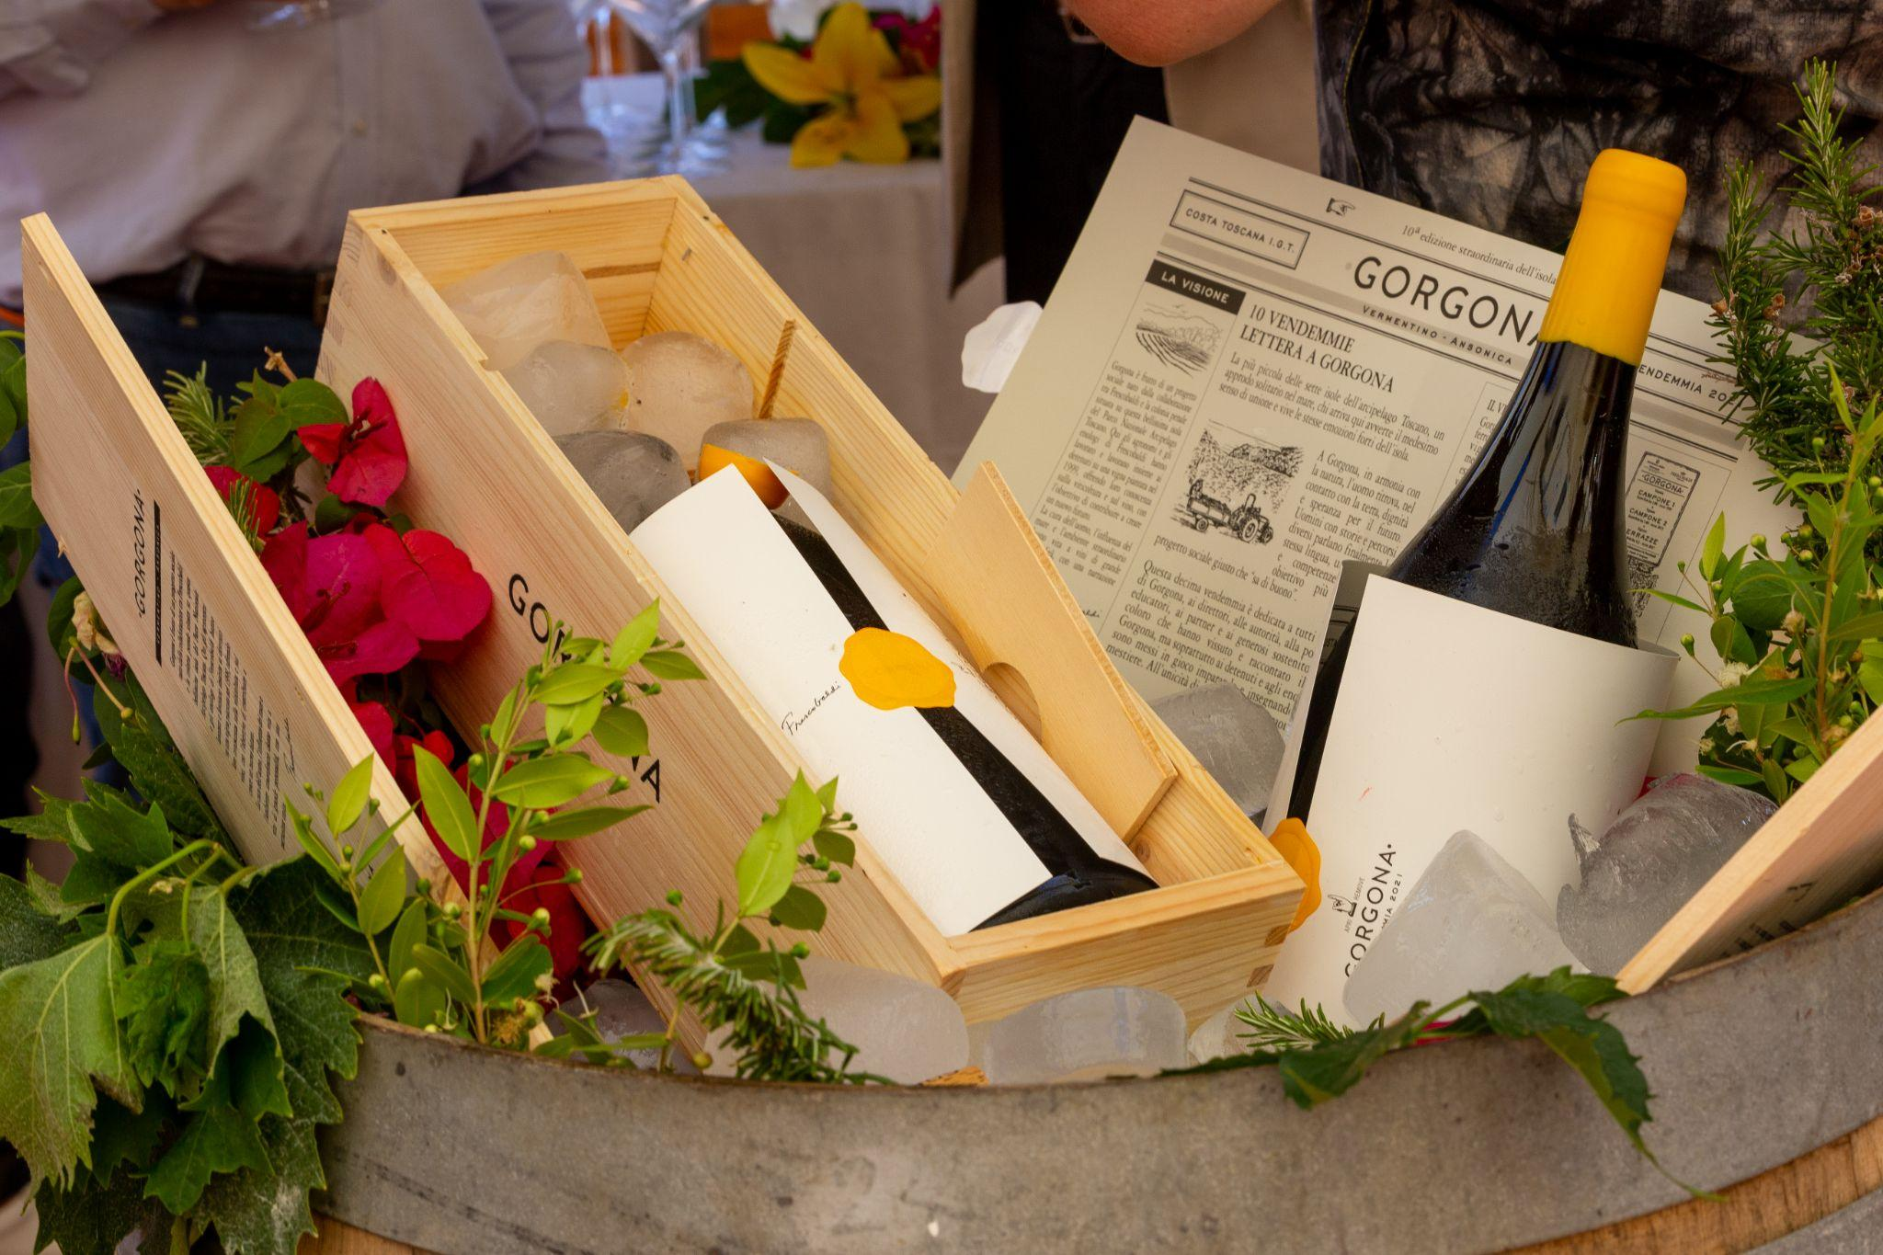

[Gorgona](https://www.frescobaldi.com/en/wines/estates/gorgona) is born from the collaboration between [Frescobaldi](https://www.frescobaldi.com/en/) and the Gorgona Penal Institute, a unique wine produced by the island’s inmates.

#### **Strategic Framework for premiumization: Scope and Focus**

A successful premiumization strategy should start by determining the appropriate scope and focus, tailoring these company’s ambitions, risk tolerance and willingness to invest and time horizon to achieve premiumization goals.

The scope of premiumization considers whether brands want to pursue premiumization within their existing price range, making small yet impactful improvements to perceived value or alternatively, shift to an entirely new price range.

While premiumization with the same price range can be achieved with minimal updates, moving to a higher price range is a more involved process where risk tolerance and investment need to be carefully assessed.

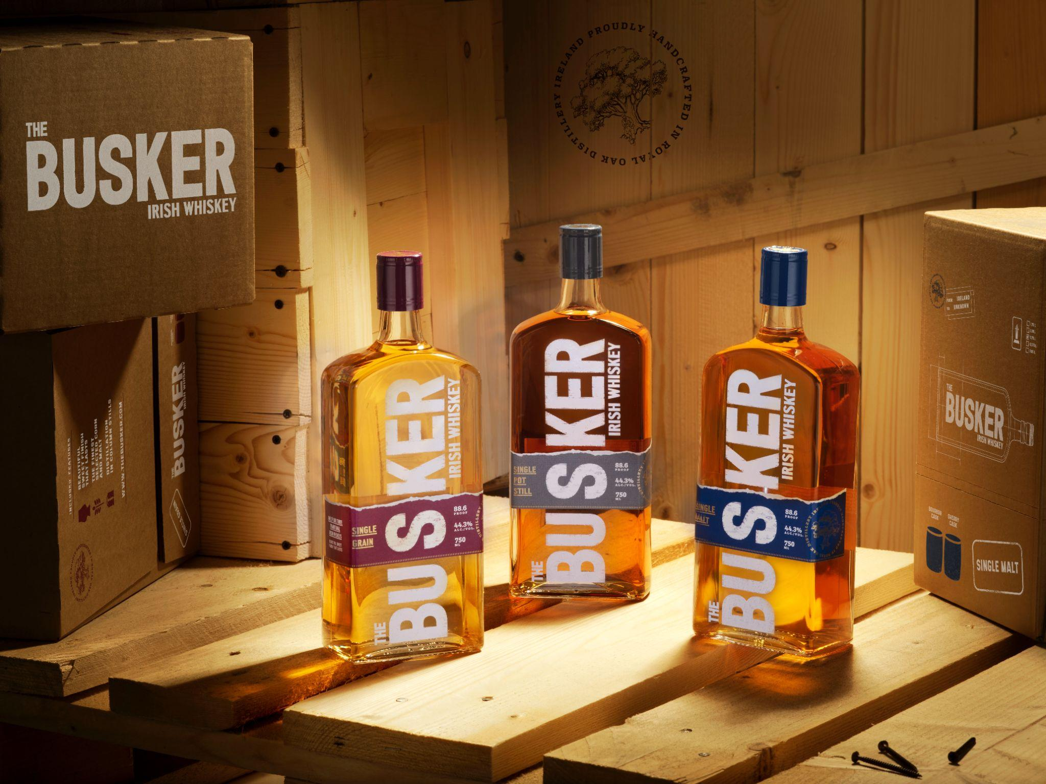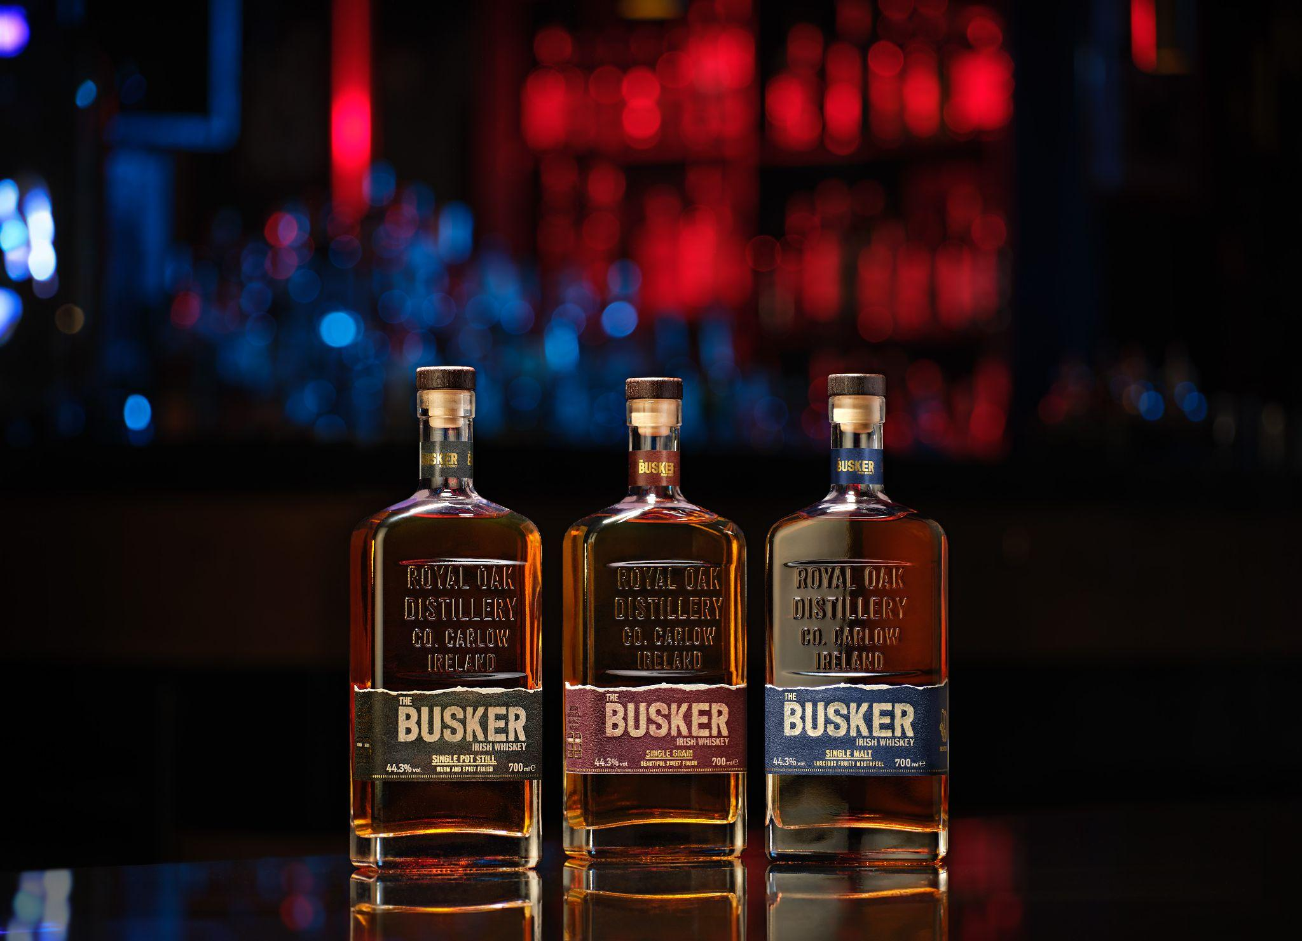

*Old packaging vs new packaging*

For example, premiumization within the same price point might involve refining a product’s packaging or storytelling to appeal more strongly to emotional and symbolic values. On the other hand, moving to a higher price position might require creating a new product line with exclusive characteristics, acquiring brands in the desired price position, or assets to justify the new position such as single vineyards wines or limited editions spirits.

The focus of premiumization defines whether a brand applies its strategy to a single product or across an entire portfolio. For wine and spirits brands, focusing on a single brand often means enhancing or rebranding one flagship product to elevate its perceived value, such as upgrading packaging or introducing special editions that add exclusivity and emotional value.

#### In contrast, a portfolio or company wide focus involves raising the price/value perception of multiple brands or lines under a single umbrella. This approach often requires creating new brands entirely or acquiring brands in the desired price positions. Whichever approach is chosen, the broader the focus, the longer the time, cost and risks associated with it.

#### **Premiumization as a Long-Term Commitment**

Premiumization is not a one-time adjustment but an ongoing process that requires consistent investment in consumer experience and perception. The best premium brands are intentional in everything from product development to customer engagement. By carefully balancing quality, brand image, and targeted marketing, wine and spirits brands can successfully elevate their perceived value, creating products that consumers are willing to pay more for and feel a deep connection with.

With the right strategy, premiumization becomes a powerful way for brands to differentiate themselves and foster a loyal, value-driven consumer base. It’s a challenging but rewarding path that requires attention to detail, an understanding of consumer desires, and a commitment to excellence across all touchpoints.